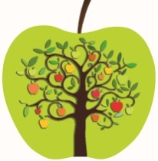 **DEBLOK TOURS AND TRAVELS**

277, B. B. GANGULY STREET KOLKATA-700012

ROOM NO-305, 3Rd Floor

MOBILE NO--9007884425

Office No: 033-4072 9601

[www.debloktoursandtravels.com](http://WWW.DEBLOKTOURSANDTRAVELS.COM)

debloktoursandtravels@gmail.com

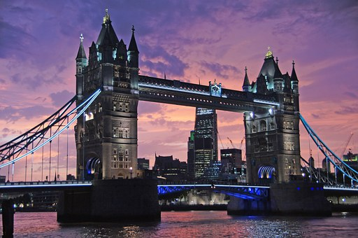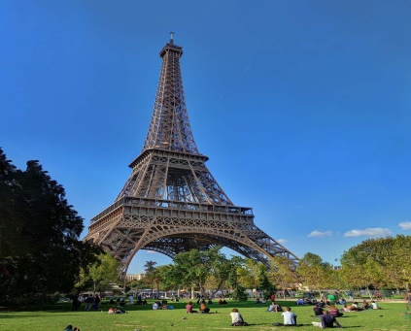

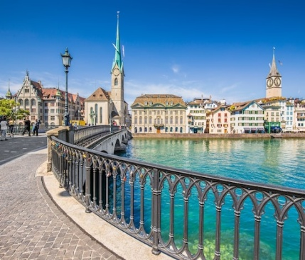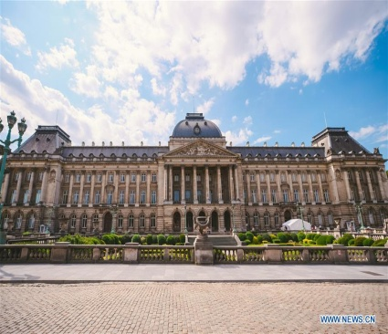

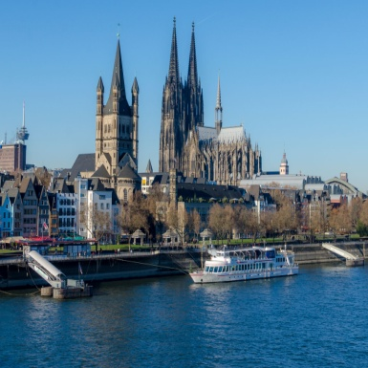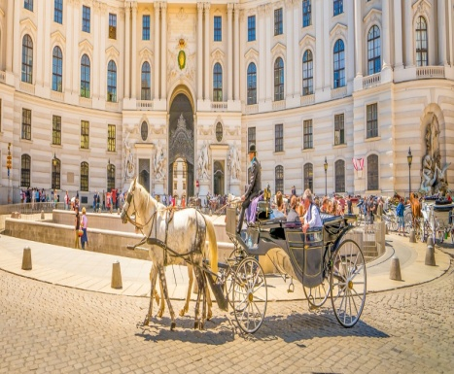

EUROPE WITH LONDON

**13 Nights/14 Days**

UK, The Netherlands, Belgium, France, Switzerland, Liechtenstein Austria, Italy, Vatican City

Tour Highlights:

* Visit the London Eye, Madame Tussauds, London city tour
* Visit the Madurodam, Amsterdam Canal Cruise, Wooden shoe & cheese

factory & Windmill photostop

* Orientation tour of Brussels
* City tour of Paris, Level 2 Eiffel tower & river Seine cruise
* Included excursion of Titlis with Ice flyer & Lucerne
* Orientation tour of Innsbruck & entrance to Swarovski Showroom
* Private Taxi to Venice Island with Murano glass demonstration
* Guided walking tour of Florence
* Guided city tour of Rome with visit to St Peters square & Basilica
* Visit to the leaning tower of Pisa
* Services of an experienced, multilingual tour manager on 24 hrs basis
* Optional excursion to Mt.Jungfrau & Interlaken

**Day 01 – Arrive into London**

Welcome to London– One of the world's most visited cities, London has something for everyone: from history and culture to fine food and good times. Our Tour Manager will meet you at the arrivals hall after immigration & transfer to the hotel. London is as much about wide-open spaces and leafy escapes as it is high-density, sight-packed exploration. A tireless innovator of art and culture, London is a city of ideas and the imagination.London is immersed in history, with more than its share of mind-blowing antiquity and historic splendour. London’s buildings are eye-catching milestones in the city’s unique and compelling biography, and a great many of them – the Tower of London, Westminster Abbey, Big Ben – are familiar landmarks. On arrival Check in & free time. Enjoy a comfortable overnight stay at the hotel.

**Meals: Lunch & Dinner**

**Day 02 – Half day London City Tour and London Eye**

After breakfast, we embark on a city tour of London, which includes sights such as Buckingham Palace, Piccadilly Circus, Regent Street, Oxford Street, Marble Arch, Hyde Park, Regent Park, Trafalgar Square, The Strand, The Big Ben, The Houses of Parliament, Westminster Abbey, London Eye, Tower of London, Tower Bridge, St. Paul's Cathedral, White Hall and 10 Downing Street (the Prime Minister's residence).

Enjoy a ride atop the famous London Eye, situated in the heart of London, from where you can get amazing panoramic views of the city, and such sights as: Westminster Bridge, the Victoria Embankment, the Saatchi Gallery and County Hall. Enjoy a comfortable overnight stay at the hotel.

**Meals: Breakfast, Lunch & Dinner**

**Day 3: Madame Tussauds and Free time at Oxford Street, Overnight Ferry**

After breakfast, we move on to experience the glittering world of fame at one of London's most popular attractions, Madame Tussauds Wax Museum. Here, you will have the chance to see super-realistic wax figures of your favorite stars like (Daniel Craig, Lady Gaga, George Clooney, The Beckhams), the Bollywood gathering (studs Hrithik Roshan and Salman Khan) and the Royal Appointment (the Queen, Harry, William and Kate) as well as other world famous celebrities.

Free time at Oxford street. Oxford Street famous for unrivalled shopping experience. Oxford Street is one of the Europe's busiest shopping street where half a million visitors visits daily to approx 300 shops. Later we proceed to Harwich to board the overnight ferry to Holland.

**Meals: Breakfast, Lunch and Dinner**

**Day 4: Amsterdam Arrival, Canal Cruise, Madurodam, Windmills, Wooden Shoe Factory & Cheese Farm**

Welcome to Amsterdam. Soak in the quaint, relaxing atmosphere of the vibrant Dutch capital while cruising along the UNESCO World Heritage-listed canals. Learn interesting information about Amsterdam's highlights and uncover secrets behind each historical building. You’ll have plenty of time to take some great photos of some of Amsterdam's iconic sites such as the Royal Palace, the National Monument, St Nicholas Church, Munt Tower, the

famous Golden Bend, the Skinny Bridge and much more! Enjoy a complete overview of Amsterdam and its beautiful architecture on the canal cruise.

We proceed to visit Madurodam, which is home to a range of famous Dutch landmarks, historical cities and large developments downsized to a range of 1:25 scale model replicas. See Holland’s most famous attractions in one fun, interactive place! Located in The Hague, the Madurodam miniature park features model replicas of the

Netherlands’ most important landmarks, landscapes, museums and more, including the Rijksmuseum, Binnenhof, the Port of Rotterdam and typical Dutch houses, windmills and tulip fields. A must for everyone, no matter what age, Madurodam offers a fantastic look at what makes Holland so unique with educative information, fun facts and intriguing sights.

We also visit a wooden shoe factory of Holland and witness a free demonstration of the history, traditions and the making of authentic Dutch wooden shoes along with a visit to a Cheese Farms. After the demonstration, take a short stop for a photograph at a windmill, one of the most distinctive sights of the Netherlands. Enjoy a comfortable overnight stay at the hotel in Netherlands.

**Meals: Breakfast, Lunch and Dinner**

**Day 5 – Brussels Orientation Tour, Onto Paris**

Today, we proceed to the Belgian capital, Brussels, which is the capital of the European Union. Belgium's fascinating capital, and the administrative capital of the EU, Brussels is historic yet hip, bureaucratic yet bizarre, self confident yet unshowy, and multicultural to its roots. All this plays out in a cityscape that swings from majestic to quirky to rundown and back again. Organic art nouveau facades face off against 1960s concrete developments, and regal 19th-century mansions contrast with the brutal glass of the EU’s Gotham City. This whole maelstrom swirls out from Brussels’ medieval core, where the Grand Place is surely one of the world’s most beautiful squares.

We begin the orientation tour with the Grand Place along with the guild houses which is the central square of Brussels, apart from this we also see the Manneken Pis, Royal Palace, Royal Park, City Museum, Town Hall, Palace of Justice and the Museum of Fine Arts. We also take a photo-stop at the Atomium, which was built for the 1968 World expo. We continue our journey to Paris. Welcome to the city of Paris. Paris has a timeless familiarity for first-time and frequent visitors, with instantly recognizable architectural icons, along with exquisite cuisine, chic boutiques and priceless artistic treasures. Enjoy a comfortable overnight stay at the hotel in Paris

**Meals: Breakfast, Lunch and Dinner**

**Day 6: Panoramic Tour of Paris, Eiffel Tower Level 2, River Seine Cruise**

After breakfast, we embark on a panoramic tour of Paris where you will have the witness sights such as Champs Elysees, Opera Garnier, Arc De Triomphe, Louvre Palace, Grand Palais, Petit Palais, National Assembly, Alexandre Bridge, Concorde Square, Magdalene Church,

Trocadéro Square, Conciergerie and Notre Dame Cathedral. Later, we continue to the centre of Paris to visit the most famous attraction in Paris, the Eiffel Tower. Built in 1889, and designed by the young engineer Gustav Eiffel, the tower stands 324 metres (1,063 feet) tall. Enjoy spectacular views of the city from the Second level. Later we proceed to experience a panoramic boat cruise along the River Seine. With entirely glass topped vessels, these exquisite boats are constructed to explore the breathtaking views of the Parisian monuments such as the Eiffel Tower, the Orsay Museum, the Notre Dame Cathedral, Paris’ own Statue of Liberty as well as many other landmarks.Enjoy a comfortable overnight stay at the hotel in Paris.

**Meals: Breakfast, Lunch and Dinner**

**Day 7: Onto Swiss**

After breakfast today, we proceed to Switzerland, which is a landlocked country in the cultural and geographical centre of Europe. Renowned for its snowbound Alps, lush green meadows and fresh water lakes, the prosperous country of Switzerland is blessed with a distinct character and dynamism, along with the gorgeous hills, cascading waterfalls, fruit loaded orchards and green blossoming gardens, the beauty of the nature in Switzerland is simply remarkable. Enjoy a comfortable overnight stay at the hotel in Switzerland.

**Meals: Breakfast, Lunch and Dinner**

**Day 8: Mt. Titlis with Ice Flyer and snow park and Lucerne Orientation Tour of Lucerne**

After a delectable breakfast, join us to visit Mt. Titlis. The 45 minute ride across 2 cable cars is awe-inspiring as you'll witness the scenery change from green meadows and scenic lakes to snow clad mountains. The last leg of the ride is on the famous Rotair, which is the world's first revolving cable car that offers an awesome 360-degree panoramic view of the snow-covered valleys, glaciers, lakes, forests, and mountains in Switzerland. Later, we proceed to Lucerne which is a beautiful city located at the northern tip of Lake Lucerne, where you'll see the Lion Monument called Lowendenkmal. Thereafter, stroll along the banks of Lake Lucerne to witness attractions like the Kapellbrucke (The Chapel Bridge) and the Spreuerbrucke, two traditional wooden bridges of Lucerne. From here, move on to enjoy your free time shopping for something typically Swiss such as a prestigious brand of watch or jewellery, fashion or stylish accessories. The Old Town is pedestrianised, and the lively new part of town also boasts a good selection of shops with artisan produce, plants and handicrafts. Enjoy a comfortable overnight stay at the hotel in Switzerland.

**Meals: Breakfast, Lunch and Dinner**

**Day 9: Excursion to Mt Jungfraujoch and Interlaken (Optional Tour)**

After a delectable breakfast, avail the once in a lifetime opportunity to visit Jungfraujoch, also known as the “Top of Europe”. It lies at a height of 3,466 meters (11,371 ft) above sea level in the Bernese Alps, it is one of the UNESCO natural world heritage sites. The Jungfrau region is is the most glaciated part of the European Alps, containing Europe's largest glacier and a range of classic glacial features, and provides an outstanding record of the geological processes that formed the High Alps. Tourists are often amazed at the scenic splendour they witness from the Cog-Wheel train that climbs up to a height of 11,333 feet to reach Jungfraujoch, the highest railway station in the world. The Cog- Wheel train is one of the best, most incredible train journeys in the world. The views of Switzerland from atop the mountain are amazingly panoramic and breathtaking.

Later, we drive to Interlaken, which lies in the Bernese Oberland on an alluvial plain, between Lake Thun and Lake Brienz and is surrounded by sparkling streams, fantastic waterfalls and an extraordinary mountain scenery including the famous peaks of the Eiger, the Moench and the Jungfrau. Interlaken is the adventure capital of Europe. Enjoy a comfortable overnight stay at the hotel in Switzerland.

**Meals: Breakfast, Lunch and Dinner**

**Day 10: Visit to Vaduz, Innsbruck Orientation tour and Swarovski Showroom**

After breakfast today, proceed to visit the beautiful city of Vaduz which is in the landlocked alpine country of Liechtenstein – the 6th smallest country in the world and also the richest German speaking country. Vaduz, the capital city, gives an opportunity to tourists to appreciate some of the many surviving medieval, Gothic, and Baroque structures. We proceed to Innsburck, the capital of Tyrol. This city has the most picturesque backdrop, nestled in the gorgeous deep valley of the River Inn. It is an amazing town with a rich history that is evident through the large number of museums and landmarks. On arrival, we proceed on an Orientation tour of Innsbruck seeing sights such as Goldenes Dachl, Helblinghaus, Stadtturm, Triumphforte, Hofkirsche and Hofburg.

Later, we proceed to Swarovski Showroom, which is known for its amazing collection of precision-cut lead crystal glass. Witness a crystal-themed indoor park, different special exhibitions, a series of classic concerts where a glittering world of crystals awaits you. Enjoy a comfortable overnight stay at the hotel.

**Meals: Breakfast, Lunch and Dinner**

**Day 11: Venice Orientation tour and Murano Glass Factory**

Today we head to the most romantic city in Italy, known for its famous gondola rides and its amazing architecture. That’s correct ! Venice ! which is known as the Queen of the Adriatic. Also fondly called La Serenissima, Venice is built on 180 islands that are connected by over 400 bridges, with hundreds of canals criss-crossing the town. We take a boat ride to reach Venice Island enjoying the scenic view as we pass the famous bridge of Sighs and the Basilica di San Marco and head to St Mark’s Square where we witness sights such as the Bridge of Sighs, the Ducale Palace, St. Mark's Basilica and the Clock tower which are part of this romantic city. We also visit the Murano Glass factory where we have an opportunity to see how the Murano glass is made and see where the glass is handled to create fabulous designs. An expert master will create two objects with the most popular techniques, blowing and sculpture. Enjoy a comfortable overnight stay at the hotel.

**Meals: Breakfast, Lunch and Dinner**

**Day 12 – Walking tour of Florence and Leaning Tower of Pisa**

After a delectable breakfast, we proceed to Florence, which is a stunning medieval city divided into two parts by the River Arno. Florence is considered one of the most beautiful cities in the world with its overflow of palaces, churches and museums filled with masterful paintings and sculptures. Cradle of the Renaissance, romantic, enchanting and utterly irresistible, Florence (Firenze) is a place to feast on world-class art. We begin our walking tour of Florence with sights such as Cathedral of Santa Maria del Fiore, Campanile and Baptistery along with Loggia Dei Lanzi and the Fountain of Neptune and Ponte Vecchio which is the oldest and the most famous bridge in Florence. Later, we proceed to Pisa, where we visit the famous Leaning Tower of Pisa, known to be the bell tower of the Duomo Cathedral. One of Italy's signature sights, the Torre Pendente truly lives up to its name, leaning a startling 3.9 degrees off the vertical. The 56m-high tower, officially the Duomo's campanile (bell tower), took almost 200 years to build. Over time, the tilt, caused by a layer of weak subsoil, steadily worsened until it was finally halted by a major stabilisation project in the 1990s. Enjoy some spare time to a short stroll. Enjoy a comfortable overnight stay at the hotel.

**Meals: Breakfast, Lunch and Dinner**

**Day 13 – Rome: Guided city tour, St. Peter’s Basilica and St. Peter’s Square**

After a scrumptious breakfast, we proceed to the eternal city of Rome. Rome has a history over two and a half thousand years, as one of the founding cities of Western Civilization and has been a site of major historic events and has also been the cultural centre of Europe. Rome is so filled with Christian art and architecture, wonderful sights, cultural exhibits and so much more that the city will astound you. we begin the guided city tour of Rome which includes sights such as Colosseum, Arc of Constantine, Roman Forum and Caesar's Forum. We also discover many of the renowned attractions of Rome– the Trevi Fountain; the Victor Emmanuel monument on Piazza Venezia under which lies the Tomb of the Unknown Soldier with eternal flame. Later, we visit the Vatican City, the smallest republic in the world, we visit the St. Peter’s basilica which is the largest church in the world and the center of Christianity. Take a walk among the massive Tuscan colonnades of the St. Peter’s square. Enjoy a comfortable overnight stay at the hotel.

**Meals: Breakfast, Lunch and Dinner**

**Day 14 – Departure**

After breakfast, we bid goodbye to Europe as we receive a transfer to the airport in time to board your flight back home. With an enriching experience of a lifetime, it’s time to take home happy memories of the beautiful places visited, which you will treasure for a lifetime.

**Meals: Breakfast**

**END OF TOUR**

**Hotels are 3 and 4 star**

* **London** - **Best Western Wembley Or Holiday Inn Heathrow Or Similar**
* **Amsterdam** - **NH Konigshof Or NH Rotterdam Or Similar**
* **Paris** - **Novotel Suites CDG Or Novotel Aulnay Or Similar**
* **Zurich-** **Novotel Zurich Messe Or Central Engelberg Or Similar**
* **Innsbruck** - **Alpenkoehig Or Olympia Or Similar**
* **Venice** - **Sheraton Padova Or Similar**
* **Florence** **- B&B Pisa Or Similar**
* **Rome** - **Mercure Roma West Or Best Western Triangoli Or Similar**

**Package Cost**: **INR 2,30,000/- (Per Head) + GST (5%)**

**Package Cost Includes**:

* **All air fare**
* **Cruise service charge**
* **Hotels**
* **All meals (Breakfast at hotel, Lunch & Dinner at Indian restaurant with buffet)**
* **Visa charge**
* **Travel insurance**
* **All transfers**
* **English speaking Guide**
* **Tips**

**Package Cost Excludes:**

* **Telephone call charge**
* **Room service**

**\*\*\*\*\*\*\*\*\*\*\*\*\*\*\*\*\*\*\*\*\*\*\*\*\*\*\*\*\*\*\*\*\*\*\*\*\***